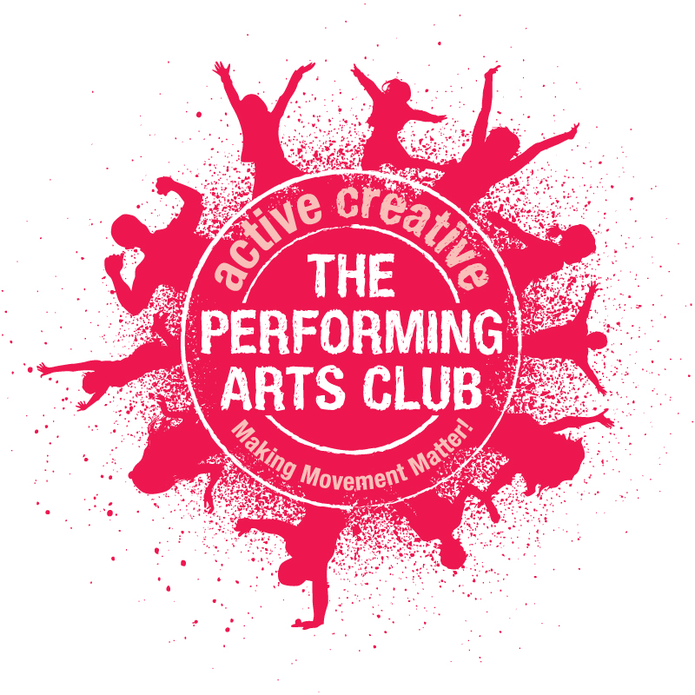

3 action packed days of fun, creative, physical and musical activities for boys and girls aged *5-13 years

Monday 3rd to Wednesday 5th April 2017 incl.

0900–1500 each day (wrap-around care 0800-1600 available)

Monday, Tuesday & Wednesday, @ Victoria First and Nursery School,

Prince Edward Street, Berkhamsted, HP4 3HA

DRAMA: working in groups, pairs and individually to explore our ‘Brilliant Books!’ theme. Developing stage and performance skills, building physical and social confidence and awareness and working creatively together towards a group performance at the end of the course.

DANCE: fun, funky and energetic – children will be jumping, jiving and ‘getting down’ to foot tapping beats whilst experiencing varied dance styles to explore our theme.

MUSIC: a terrific opportunity to sing, sing, sing! Children will be selecting a varied repertoire of music to learn. Our singing coaches encourage good musical technique but most of all, know how to make group singing so much fun!

The Performing Arts Club will provide tuition and a t-shirt, and organise snacks and drinks to keep everyone refreshed throughout the three days. Please provide your child with a packed lunch in a named container and a named water bottle every day.

Each day will start promptly at 0900 and finish at 1500. We can offer extended hours from 0800 to 1600 on each day. (£5 per child, £3 per sibling, per morning or afternoon session. Please contact us for more details.

On the final day there will be a performance at 1500, the children will perform some of the material they have been exploring over the three days. This is a terrific opportunity for the children to enjoy learning about performance in an unpressurised, friendly environment – and moreover, a brilliant way to end what we hope will be a super three days. Families and friends are welcome to come along and watch their children – details nearer the time!

*Children currently in Reception who are 5 years old are welcome to do this club. However, we tend to find that many five year olds still in their Reception year at school find our clubs extremely tiring and sometimes a little bit too overwhelming! Some manage absolutely fine and are able to enjoy it enormously; however parents should be aware that it’s a very structured course with little free play. From experience, we find children in Year One are more than ready – so it’s often worth waiting to ensure that your child’s first experience of The Performing Arts Club is a fantastic one. Please do contact us if you would like to discuss this on 01442 874 154.
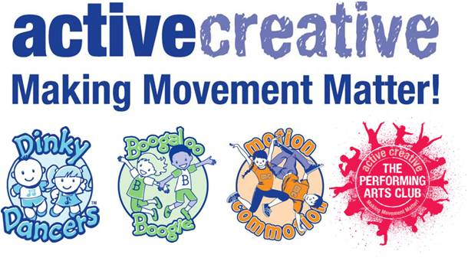
So that we can confirm your child’s place for this Easter club, we must be in receipt of a completed booking form AND payment. Please do not assume your booking is confirmed until you are in receipt of an emailed booking confirmation. Unfortunately we are unable to reserve places without both of these.
email to classesinfo@active-creative.com or call 01442 865240 www.active-creative.com

Easter Performing Arts Club 2017

BOOKING FORM

Child's Name:
Child's Date of Birth:
Child’s Age (at 3rd April 2017):
Child’s school year:
Child’s School:
Parent/Carer’s Name:
Address:
Home phone number:
Mobile phone number:
Emergency Contact Name &Number (if different):
Email address:
Does your child suffer from any medical conditions about which we should be aware?
From time to time we will take photos of children engaged in activities. Please tick this box if you do not wish your child’s photograph to be used for publicity purposes, which may include social media.
Do you give permission for a member of staff to administer medication/first aid? YES / NO

0900 – 1500 DAY  Discounted rate for The Performing Arts Club members:  Easter Performing Arts Club 3 Day Course Fee per child  Sibling does not need to be a member (Sibling discount price - £77.76) | £86.40
0900 – 1500 DAY  Standard rate (Non-members):  Easter Performing Arts Club 3 Day Course Fee per child (Sibling discount price - £86.40) | £96.00
Wraparound care £5 per child / £3 per sibling per session: Mon 8.00 - 9.00 am Mon 3.00-5.00pm
Tues 8.00 - 9.00 am Tues 3.00-5.00pm Wed 8.00 - 9.00 am Wed 3.00-5.00pm
Please make cheques payable to ‘Active Creative’. Cheque will be processed on the last day of the club - Wednesday 5th April.
Post dated cheques (to 3rd April) are accepted.
We are now able to accept online payments - Ac No: 07697054, Sort Code: 09-01-29. Please put PAC'SURNAME'EAST17 as a reference. Without a reference AND booking form your place(s) will not be confirmed.
Should you need to cancel your place(s) a cancellation fee of £25.00 per child, will be redeemable.
(Please note our new bank details for transfers)

Please return the reservation form and full payment to:
Active Creative, 9 Birtchnell Close, Berkhamsted, Herts, HP4 1FE.

Please do not assume your booking is confirmed until you are in receipt of an emailed booking confirmation from us.

Please do regularly check your junk email folders and ensure your email settings ‘trust’ emails
from@active-creative.com AND @dinkydancers.com

